Strategic Workforce Planning Guide:
How to Create Your Own
Strategic Workforce Plan

Table of Contents
Introduction 2
Involve your Stakeholders 4
Strategic Drivers 5
Supply Analysis 6
Demand Analysis 7
Gap Analysis 8
Solution Formulation and Implementation 9
Monitoring and Evaluation 10
Template: Strategic Workforce Plan 11

Introduction

How to use this guide and template:
The objective of this tool is to help you create your own strategic workforce plan for your organization. This guide will explain the different sections of a strategic workforce plan and the attached workforce planning template will help you organize your own.
The template is divided into different sections according to the phases of the workforce planning cycle to help you organize your own strategic workforce plan. Each section includes questions and considerations for that phase of the cycle. Once you have created your own workforce plan for your organization, you can refer to other tools in the toolkit to implement your workforce planning strategy.
What is Strategic Workforce Planning?
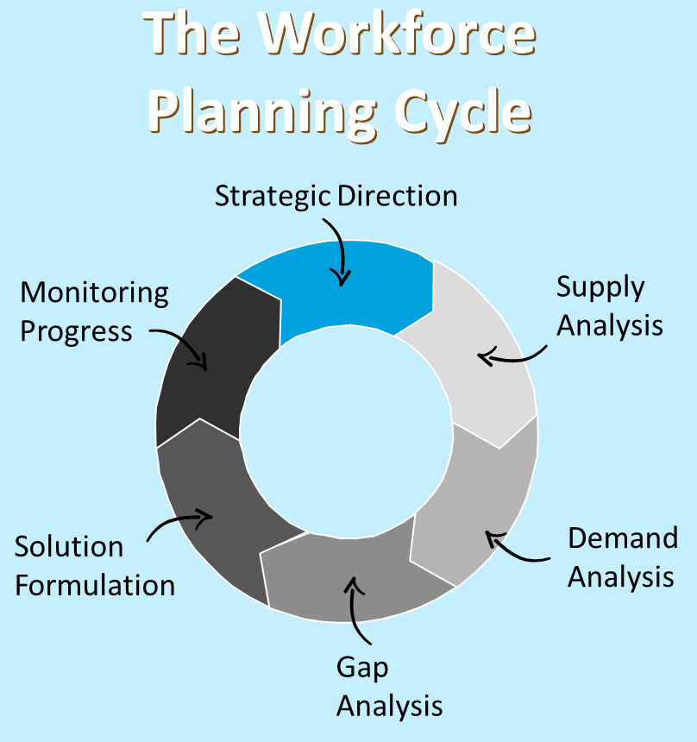
Strategic Workforce Planning is the process of analyzing, forecasting and planning workforce supply and demand, assessing gaps, and determining targeted talent management interventions to ensure that an organization has the right people – with the right skills in the right places at the right time – to fulfill its mandate and strategic objectives.
Strategic Workforce Planning is composed of six phases:
- Strategic Direction
- Supply Analysis
- Demand Analysis
- Gap Analysis
- Solution Formulation
- Monitoring Progress

Why do Strategic Workforce Planning?
The federal government environment today is one of rapid change and uncertainty. Changing political direction, rapid technology advances, and increased pressure to do more with less, are just some of the factors leading to increased pressure on organizations, to ensure that the required talent is in place to effectively respond to changing business priorities.
When properly implemented, workforce planning ensures an organization has the right people with the right skills in the right places at the right time. These factors, people, skills, positions, and timing, need to be aligned to ensure your organization is able to continue to meet its mission.

Common challenges workforce planning can help resolve:
Change in Mandate
Realignment
Skill Gaps
Budget Cuts
By strategically planning its workforce, an organization can ensure that it has access to the skills needed to meet current and future mission needs despite changes to budget.

A change in an agency’s mandate can mean a change in the scope or needs of its work. By having an active workforce plan an agency will be in a position to proactively reshape its existing and future workforce skills profile to meet new mission needs.
Often times an organization’s skills needs will shift over time. By using work-force planning, an organization will know where it has existing skillsets, and can internally streamline position transitions with relative ease.
By strategically planning its workforce, an organization will know where there is a skill need for its current and future state, allowing it to strategically plan talent distributions to meet mission needs of today and tomorrow.

Involve your Stakeholders

Who do you need to involve?
Developing a workforce plan is no small feat. There are many factors to consider, perspectives to acknowledge, and moving pieces to track during the process. In developing your workforce plan it is important to involve the right stakeholders at the right time in the process. Not every stakeholder will have input at each point in the process, however, giving them an opportunity to be involved will ultimately help to secure buy-in when the time comes to implement the plan.
Who should you talk to?
The image below identifies examples of possible stakeholders to engage for different stages of the workforce planning cycle.

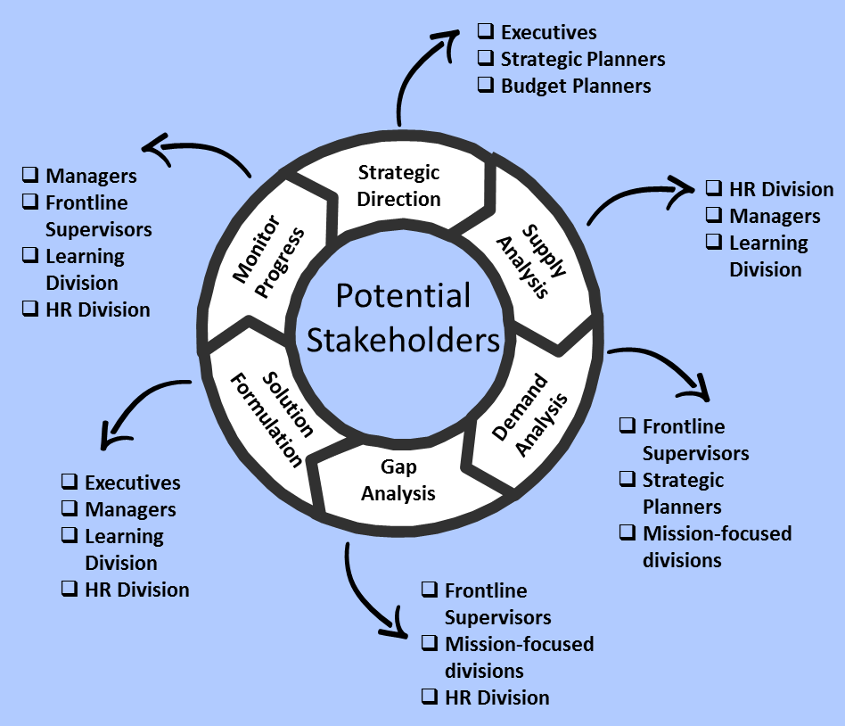

Strategic Drivers

What direction is your organization going?
Determining the strategic direction for your workforce plan involves understanding key mission goals and future objectives set by organization leadership and how the workforce needs to be aligned to achieve them.
Questions to consider:
- What are the expected program changes over the next 1-3 years? What will drive these changes?
- What are the short-term and long-term plans/strategies?
- What are the specific workforce challenges the organization is expected to face in the short and long-term?
- What challenges exist in the emerging market, economic and political environments?
- What legislative, policy or regulatory changes may impact your organization?
Common sources of information:
- NIH and/or IC Strategic Plan
- Business plans
- Discussions/interviews with executive leadership

Supply Analysis

What is your workforce supply?
Conducting a supply analysis involves understanding the current workforce and how it is projected to change over time, due to attrition and other trends. This phase is about painting a picture of the organization’s workforce terms of the right number of people with the right skills.
Questions to consider:
- How well does the current workforce align/support your business strategy?
- How many employees are at each organizational level?
- What are your attrition rates? How will turnover affect your organizations ability to deliver services?
- What is the current distribution of employee years of service?
- How much of your workforce will be retirement eligible in the coming years? Are these individuals in leadership/mission critical/hard to fill positions?
- Will employees who have left be replaced? If so, will it be done with internal or external hires?
- What are the costs of replacing talent internally vs. externally?
Examples of data types:
- Number and types of employees | - Pay grade
- Salary and benefits | - Competencies
- Workforce diversity (age, gender, race, etc.) | - Location
- Years of service | - Veteran status
- Retirement eligibility | - Turnover data

Demand Analysis

What is your workload demand?
Conducting a demand analysis involves understanding the amount and type of work the organization has historically handled, currently handles, and/or anticipates handling at a specific point in the future. This information is used to project the number of staff resources (headcount and skills) needed to perform work in various job functions, taking into consideration current workload and emerging drivers.
Questions to consider:
- How is workload measured in the organization? What are the units of measurement?
- How many people does it take to accomplish the work? Is this anticipated to change in the future due to efficiency gains or program changes?
- Based on the strategic plan (or other projection of work), how much work is anticipated per year?
- Does the supply of employees meet the anticipated demand?
Examples of workload metrics:
- # of widgets produced | - Listing of key tasks
- # of audit cases reviewed | - Priorities of key tasks
- # of patients seen | - Amount/percent of time spent performing tasks
- # of payments processed | - Territory covered

Gap Analysis

What workforce gaps do you have?
This phase involves understanding the gaps between workforce demand and supply and to define top priority gaps with the greatest impact on organizational performance. Depending on your particular supply and demand analysis, you could have workforce gaps in different areas such as skills, competencies, staff numbers, location, occupations, etc.
Questions to consider:
- What gaps do you see between your workforce supply and workforce demand data?
- Which gaps are most critical considering your strategic goals?
- How would you prioritize your gaps in terms of what to address first?
- Which gaps are most difficult to close? Easiest?
- Do some gaps have more of an impact on organizational performance than others?
Common types of workorce gaps:
- Skills - Current staff do not have the skills needed to accomplish the work that needs to be done.
- Staffing Level - Current staffing levels do not meet the required workload demand.

Solution Formulation and Implementation

What is the appropriate solution?
Now that you have conducted a supply and demand analysis and determined your critical gaps, you are ready to determine the appropriate workforce interventions to close those gaps and enable your organization to meet its strategic goals.
Questions to consider:
- What existing workforce intervention strategies can you leverage?
- Are there strategies other federal agencies faced with similar problems we can leverage?
- Do you have multiple critical gaps? Do you need a multi-pronged approach?
- What factors might impede the success of your strategy (unions, federal law, organizational policies, etc.)?
- What will the short-term implementation activities be? What will the long-term activities be?
Examples of intervention strategies:
- "Right-Size" programs | - Consolidate/centralize functions
- Administrative efficiencies | - Re-engineer business processes
- Hiring controls | - Leveraging technology
- VERA/VSIP/RIF | - Strategic Sourcing (outsource to 3rd parties)

Monitoring and Evaluation

Is the strategy working?
Now that you have implemented your intervention strategy, how do you tell if it worked? It is important to regularly monitor the performance of your implemented workforce planning solutions and their impact on the gaps they were designed to address, and to continuously improve solutions to maximize their effectiveness. As the strategic direction, workforce supply, and workload demand changes over time, strategies need to be updated accordingly.
Questions to consider:
- How will workforce solutions be monitored and how will progress be measured? What metrics or key performance indicators will be used?
- What are the implementation’s critical success factors?
- How will revisions to the approach be implemented? Have there been changes in the internal or external business environment that would cause the plan to need revision?
- Has the organization established processes to collect relevant workforce data and trends for this plan?
Techniques to help you evaluate progress:
- Program process reviews
- Employee questionnaires or assessments
- Customer questionnaires or assessments
- Meetings, surveys, focus groups
- Organization performance assessments
- Lessons learned sessions

Template: Strategic Workforce Plan

- Executive Summary
Executive Summary for overall Strategic Workforce Plan
Provides a business rationale for the development of the strategic workforce plan. Provides a high level overview of the information contained in the rest of the template (stakeholders, strategic drivers, supply and demand analysis, gap analysis, solution formation and implementation, and monitoring and evaluation).

- Stakeholders Involved
List of Internal and External Stakeholders

- Strategic Drivers
Short and long-term organizational goals
Expected program changes over the next 1-3 years and what drives these changes
Specific workforce challenges the organization is expected to face in the short and long-term
Challenges in emerging market, economic, and political environment
Stakeholder engagement strategies
Upcoming legislative, policy, or regulatory changes that may affect organization

- Supply Analysis
Current workforce demographic
Assessment of workforce alignment/support to current business strategy and needs
Number of employees at each organizational level
Attrition rates and the effect on organization’s ability to deliver services
Current distribution of employee years of service
Overall workforce retirement eligibility in (X) years
Workforce retirement eligibility in (X) years for leadership/mission critical/hard to fill positions
Plans (if any) to fill behind employees who have left (recruitment sources, internal/external hires, grades, etc.)
Costs of replacing talent internally vs. externally

- Demand Analysis
Plan or strategy to measure workload in the organization (include units of measurement)
Amount of work anticipated per year, based on the strategic plan (or other projection of work)
Number of people needed to accomplish current workloads.
Any anticipated workload changes due to efficiency gains, program changes, or other circumstances

- Gap Analysis
Describe the gaps between your workforce supply and workload demand
Identify what gaps are most critical considering the strategic goals
Prioritize the gaps in terms of what to address first, second, third, etc.
Identify which gaps are most difficult and easiest to close
Identify which gaps have more of an affect on organizational performance

- Solution Formulation and Implementation
Identify any existing workforce intervention strategies
Identify any applicable strategies other federal agencies used when faced with similar problems
State the most critical gaps to address
Assess if the solution need a multi-pronged approach (if so, describe possible approaches)
Identify any factors that might impede the success of the strategy (unions, federal law, organizational policies, etc.)
Describe short-term and long-term implementation activities

- Monitoring and Evaluation
Describe how workforce solutions be monitored and how progress will be measured (include any metrics or key performance indicators)
Identify any factors critical to the success of workforce planning and implementation efforts
Describe how revisions to the approach will be implemented. Identify any changes in the internal or external business environment that would cause the plan to need revision
Describe the organization’s established processes to collect relevant workforce data and trends for this plan

For example and reference purposes, four sample workforce plans exist on the NIH Workforce Planning Toolkit site (OHR) and are available in the public domain.

