About
Released in June 2012 by Human Resources Systems, Analytics & Information Division (HRSAID) within the Office of Human Resources (OHR), SMARTHR increases efficiency by automating specialized reporting tasks and bridging reporting gaps across multiple HR and non-HR systems to promote a comprehensive on-demand assessment of the organization and human capital topics for NIH-wide audiences.
Modules
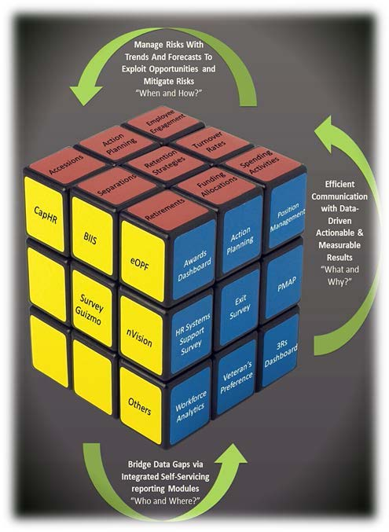
- PMAP: Enables program areas with the ability to capture, consolidate, report, certify, and submit PMAP ratings and awards securely and efficiently to HR.
- Awards Dashboard: Enables program areas with the ability to effectively monitor awards spending by generating and tracking allocations against processed and pending awards transactions.
- 3Rs Module: Enables program areas with the ability to manage and distribute obligations and expenses associated with Recruitment, Relocation, and Retention (3Rs) incentives.
- Exit Survey Report: Compiles survey feedback with workforce transaction information to provide program areas with an insight into the opinions of separating employees to improve retention strategies.
- Action Planning: Provides historical trends and retention best practices (recommended action items for top reasons for separation used in public and private sectors) to facilitate retention strategies by program areas.
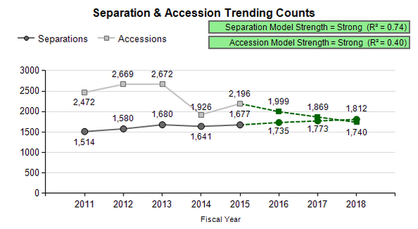
- Workforce Analytics: Provides program areas with a mechanism to identify NIH workforce demographics, trends, and projections to facilitate workforce planning.
Access and Technical Support
Access and technical support requests may be submitted to HR Systems Support Helpdesk via https://intrahr.od.nih.gov/wits/index.htm. SMARTHR does not require any user licenses and does not charge your organization for access and support. The only requisite is authorization by your Executive Officer (or Designee) prior to being granted access. To log into the SMARTHR tool, go to https://smarthr.od.nih.gov.

